# CS 255 System Design Document Template

This template lays out all the different sections that you need to complete for Project Two. Each section has guidance to prompt your thinking. You will need to continually reference the interview transcript as you work to make sure that you are addressing your client’s needs. There is no required length for the final document. Instead the goal is to complete each section based on what your client’s needs are. Remove this note when you are finished, and replace all bracketed text with the relevant information.

## UML Diagrams

### UML Use Case Diagram

### UML Activity Diagrams

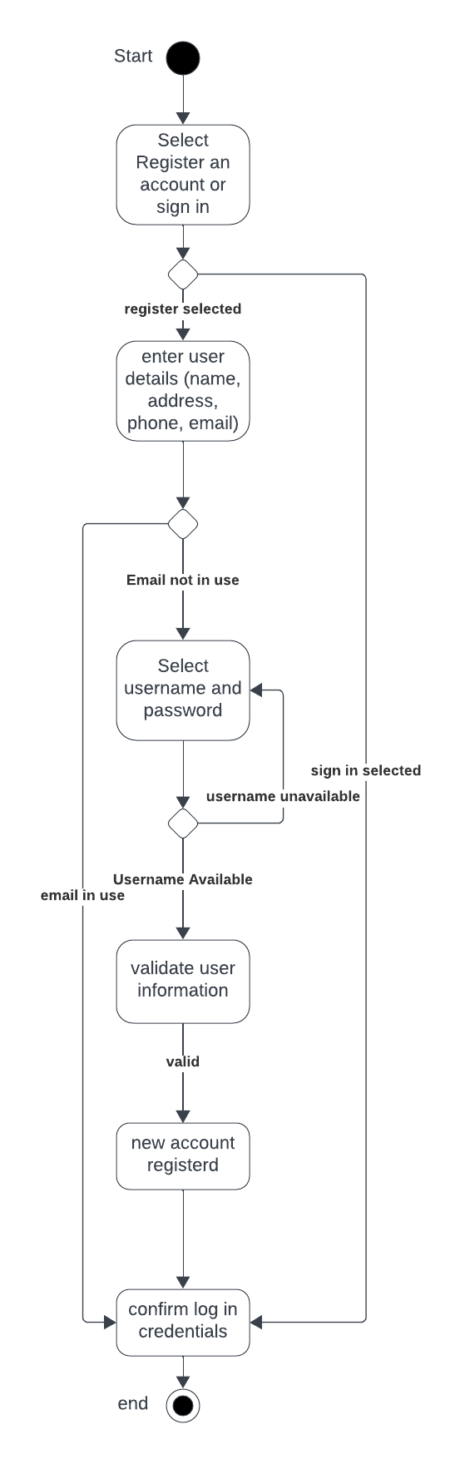

### UML Sequence Diagram

### 

### UML Class Diagram

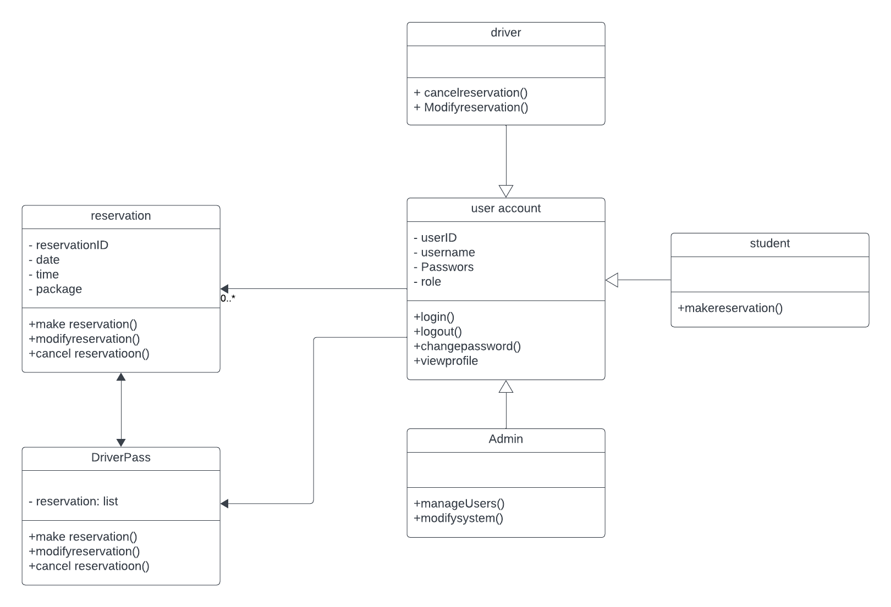

## Technical Requirements

*The technical requirements for the DriverPass system encompass key elements for effective implementation. Hardware needs include a robust server infrastructure and a dedicated database server. Software requirements involve a dynamic web application framework, a reliable Database Management System (DBMS), and security software for data encryption and protection. Real-time connectivity software is crucial for synchronization with the DMV. Tools such as an Integrated Development Environment (IDE) and version control systems are essential for development. Infrastructure relies on cloud services for hosting, requiring continuous high-speed internet connectivity. Compliance and integration considerations involve regulatory compliance software and integration protocols for secure data exchange with the DMV. These components collectively ensure a resilient, secure, and responsive DriverPass system.*